MULTI-ACCOUNT ACCESS CARD SYSTEM WITH MULTI-MODAL AUTHENTICATION ON BANKING TRANSACTIONS
T. Monisha1 , J. Reshma2 , S. Shalini3

12 UG Scholar, Department of Computer Science and Engineering
3 Head Of The Department (HOD), Department of Computer Science and Engineering
123 Prince Dr. K. Vasudevan College of Engineering and Technology, Chennai, TamilNadu, India
---------------------------------------------------------------------***---------------------------------------------------------------------

Abstract – The demand for streamlined banking transactions has become paramount in a time of increasing digitalization and convenience-driven financial services. The project foresees an improved approach to managing multiple bank accounts using single access card. Designed to work together with the existing ATM infrastructure, the system allows users to access and perform any transaction on any of their bank accounts through a single Smart card. Customers, via a user-friendly interface can choose their specific account; verify them by entering a pin password number, and use this method to do things like take money from the account or transfer it elsewhere by means of bio-metric authentication. Sensitive data is protected from unauthorized access and other fraudulent activities through secure encryption methods, among other protective measures. This project shows how innovation improves banking services thus providing secure and convenient way of managing different financial portfolios both for clients and banks themselves.

Key Words: Bio-Metric Authentication, Streamlined banking transactions, Single access card, Encryption, Clients, Banks, Secure, Sensitive data, Voice Recognition, Banking services, Single Smart Card, ATM infrastructure

I.INTRODUCTION

Banking and technology are developing together in the current financial services scenario thereby reshaping the means through which individuals manage their finances. Digital developments have replaced traditional and conventional banking norms, making it easier for customers to access services anywhere on earth as well as globally. The shift resulted in demand for more convenient ways of conducting bank transactions that are secure.

This project responds by introducing a breakthrough system meant to reformulate individual handling of several banks accounts. What is crucial to this initiative is the creation of one Smartcard that can be used interchangeably across multiple banks. This new strategy aims at collapsing vast complexities associated with different portfolios into one simple user-friendly interface hence increasing convenience, and productivity.

This indicates the foundation upon which our system is built; merging leading-edge technology with well-established banking infrastructure. Through combining data storage improvements, encryption, as well as authentication techniques within the system can guarantee protection of confidential financial information from unauthorized operations and deceitful actions. We have designed an architecture where several account credentials are embedded in the smart card thereby including secure authentication protocols at ATMs that meet strictest security measures on privacy.

Again, our system is designed to prioritize user experience – recognizing that any innovation in technology must be usable and accessible. Therefore, we have developed an intuitive user interface that leads the customer through selecting their bank account types, authenticating their identity using a personal PIN number and then carrying out other banking activities such as; withdrawal of money or sending money to someone else, checking balance or managing account among other transactions. We aim to resonate with people of different technological abilities and banking needs through putting the individual at the center of designing.

The work we did is essential for financial institutions that are looking for ways to differentiate themselves in a crowded market, while enhancing consumer comfort and safety. In this case, banks can have more loyal customers, trusted clients and satisfied clients who will stay with them after which they will start generating revenues if their banking experience is integrated seamlessly into their daily lives. It also gives the banks a chance for efficient operations, lower cost of transaction processes and adopting data analytics as part of business intelligence on customers’ behavior.

The project is a big step forward in banking technology and brings together innovation convenience and security that will redefine individuals’ interaction with their money. It is our goal to create a single Smart card system that allows consumers to have increased control, accessibility, and peace of mind as they manage their various financial portfolios. The project represents the vanguard of change in the digital revolution of finance which is set to remake banking for generations.

II.LITERATURE SURVEY

The development of a single Smart card system for accessing multiple bank accounts has been an innovative process involving extensive research across many different fields in banking technology. Research on multi-account access systems has explored several options to combine access to different financial portfolios such as unified bank platforms, mobile apps or digital wallets. Nevertheless, some of these remedies may require users to go through numerous log-in steps or navigate complex menus before making transactions. This is the problem addressed by our project’s integration of multi-account access into a physical card thereby making its use simpler for the user experiences.

The security of banking transactions is significantly dependent on authentication protocols, whose previous research has been focusing on robust ways to verify users’ identity and prevent unauthorized access. Authentication techniques have been investigated in many studies that have been carried out such as PINs, biometrics and two factor authentication each with its own advantages and disadvantages. Our project adopts these methods of authentication by incorporating a system that uses PINs to authenticate users and authorize transactions securely.

For the protection of sensitive financial data against cyber threats and fraud it is imperative that security measures be put in place. Some prior studies had looked at encryption options for example tokenization or even fraud detection algorithms aimed at safeguarding bank account information from unauthorized entry. Our project incorporates advanced security measures for guaranteeing the integrity, confidentiality, of user data hence minimizing the possibilities of fraudulent activities or data breaches happening.

Bank technologies must involve user experience design, whereby research has shown that improved user satisfaction and engagement can be realized through user-friendly interfaces, smooth operations as well as customized experiences. Our project applies the principles of user-centered design by capitalizing on feedback from users and usability testing so as to maximize how good the interface can be for use.

Moreover, when developing and implementing bank technologies, regulatory and compliance issues feature prominently. One study examines such legal frameworks as the PCI DSS and GDPR in terms of ensuring requirements for securing personal financial information related to sensitive data management within organizations involved in finance. When it comes to our project, we are focused on meeting relevant regulations and standards with regards safeguarding controls.

Through literature review, it has been observed that our project is an intersectional undertaking, drawing from research on many things such as multi-account access systems, authentication protocols, security measures, user experience design and regulatory compliance. Our project seeks to contribute towards the advancement of banking technology by capitalizing on the progress made in these fields and associated improvements targeting at providing customers with a convenient, safe and easy-to-use platform for managing their varied financial portfolios.

III.RESEARCH TERMINOLOGY

This project adopted a research methodology that included an all-rounded, comprehensive and systematic approach with both qualitative and quantitative methods to address multifaceted objectives and difficulties of creating one smart card system for accessing multiple bank accounts. Informed decision-making is central in our methodology.

We began by carrying out extensive literature review in the areas of banking technology, multi-account access systems, authentication protocols, security measures, user experience design and regulatory compliance. The first step was identifying key concepts, trends and best practices through this literature survey which helped us come up with a design for our system.

We did a number of things in order to get data and verify our assumptions, while on this theoretical framework. They selected to employ questionnaires and interviews that were aimed at discovering the feelings of end-users towards banking software: what they like, what annoys them and how they expect it to be. As a result of qualitative research carried out through these methodologies, we obtained insights into behavioral patterns, attitudes and needs that informed the interface, the features as well as the functionalities that can be found in the system.

Apart from qualitative researches, we also used quantitative methods to evaluate feasibility, efficiency and usability of our system. These included having representatives of end users participating in usability tests to determine system efficiency related issues or possible mistakes that might have been made by developers. Furthermore, it was important to gather statistical feedback on satisfaction or dissatisfaction level among consumers due to certain computer’s functionality features as well as rates at which customers are liable for their decisions. We continued testing our product through rigorous analysis so that its design became more user-friendly.

Apart from that, our research plan entailed the use of early versions of a prototype and pilot study to confirm that the system is technically feasible, can be used together with existing banking structures and obeys laws on finances. By partnering with industry experts, financial institutions, and technology partners we were able to verify our system’s compatibility tests, scalability techniques as well as security measures hence making it ready for real-world deployment.

Throughout the research process, we observe ethical rules and norms to safeguard interests of stakeholders and participants. This involves getting informed consent from them, not disclosing information they share privately and following specific rules laid down by relevant authorities about data protection in the business world.

The aim of this study is to develop a fully integrated smart card system through the use of an interdisciplinary approach that incorporates theoretical perspectives, data collection from real life, iterative design techniques, and partnering with all stakeholders. We had employed both qualitative and quantitative approaches to generate useful information, validate our assumptions and iteratively improve our system for securing, managing multiple bank account in a convenient user friendly way.

IV.CURRENT SYSTEM

Constricted by pin standard, conventional identification items such as PINs that are printed on ATM cards have always been the common way of authenticating users during ATM transactions. After placing their card in an ATM, users normally input their PINs to be able to access their bank accounts. However, it should be noted that this system has certain disadvantages; for example, these PINs might be easily stolen or accessed illegally through shoulder surfing or phishing techniques.

However, this method is inherently insecure because there are no additional layers of security associated with a PIN. Despite being the key mode of authentication, they still have vulnerabilities in terms of security breaches.

The current configuration is reluctant to the embedding of multi-modal biometric authentication as compared to other developed systems. Biometric authentication methods such as fingerprint, facial recognition, palm, iris and voice print identification have unique advantages in that they verify who a user is using their physical characteristics which are hard to fake or steal. Introducing these biometrics into the Automated Teller Machine (ATM) framework would strengthen security by only allowing authorized users to access their bank accounts.

Also, there is no Single Smart Card function in the existing system which would enable a single card for accessing multiple bank accounts. This feature could make it easier for users because many different cards can be made into one which eliminates carrying a multitude of cards or multiple passwords that need memorization.

The above paragraph is basically saying that the ATMs we have today are good enough in terms of basic financial transactions. In fact, there are other systems which offer more advanced capabilities in terms of ensuring safety and convenience to customers. This is why security needs to be further enhanced through such mechanisms as multi-modal biometric authentication and a Single Smart Card approach, which will help users enjoy their experience while using such services without having to fear for their personal security.

V.PROPOSED SYSTEM

It is important to design a better way of carrying out ATM transactions while taking into account the already existing restrictions and looking forward to security plus ease of use. A new era of access has come about with this breakthrough invention that combines various modes for biometric authentication in one system. This means that besides the ATM card, users will also be required to present their fingerprints, face scan or voice identification when they want to access their accounts. Additionally, the plan aims at strengthening security levels by using user’s unique physical elements that are non-replicable as well as difficult to steal such as palm prints, facial features, iris pattern or even voice recognition technology.

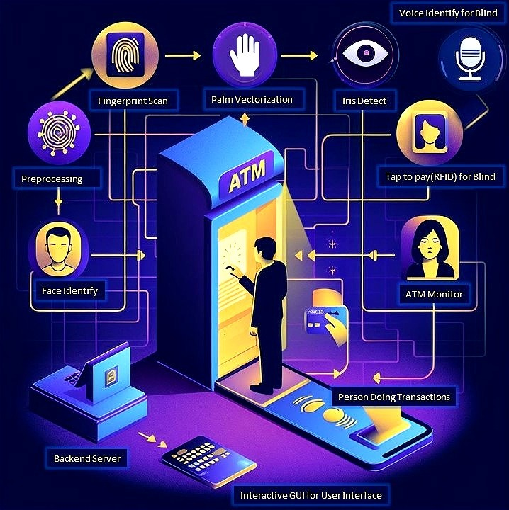

Fig 5.1 Proposed System

A situation where users approach an ATM not with a PIN in hand, but by simply presenting their unique biometric signature should be imagined. Their identity can quickly be confirmed by either taking their fingerprints or recognizing their faces to allow them access to their bank accounts with exceptional security. This move from the traditional PIN-based authentication to multi-modal biometric authentication represents a great stride in addressing concerns about unauthorized access such as shoulder surfing or phishing tactics.

Furthermore, the proposed system is designed to improve the convenience of users by introducing the Single Smart Card feature. This characteristic would enable customers to rationalize their financial management by condensing multiple bank accounts onto one card. No more carrying a wallet full of all kinds of cards or remembering many PIN numbers. Using this card, one can easily move between different accounts in a single touch thus making it easy for transactions and making it much more convenient than the existing systems.

Furthermore, the proposed system is designed to improve the convenience of users by introducing the Single Smart Card feature. This characteristic would enable customers to rationalize their financial management by condensing multiple bank accounts onto one card. No more carrying a wallet full of all kinds of cards or remembering many PIN numbers. Using this card, one can easily move between different accounts in a single touch thus making it easy for transactions and making it much more convenient than the existing systems.

VI.MODULES CLASSIFICATION

MODULE 1:

SMART CARD INITIATION:
Smart Card Initiation is a module for commencing authentication after the user has inserted his/her smart card. The data corresponding to this stage are abstracted and deciphered from the card like the user’s account number, which will help establish a secure connection with bank database.

MODULE 2:

ACCOUNT DISPLAY:
Once a smart card has been successfully inserted into the system, it then displays all of the connected bank accounts of that particular user. This module retrieves information about up to four accounts of an individual, giving them an opportunity to select an account they want to transact on further.

MODULE 3:

ACCOUNT SELECTION:
In the Account Selection module, the system requires that a user specify a certain account from among those provided. Having made the selection, one must then enter their PIN (Personal Identification Number) to authenticate themselves in order to further with the process. Thus, it is another step for confirming access to the chosen account.

MODULE 4:

BIOMETRIC IDENTITY VERIFICATION:
The Biometric Identity Verification module combines sensors and cameras to confirm your identity as a user. Once you have entered your PIN, biometric verification begins with face recognition being one of the primary aspects using camera systems as a starting point.

MODULE 5:

MULTI-MODAL BIOMETRIC VERIFICATION:
Multi-modal biometric verification techniques are employed by this module to increase security. Initially, through the use of camera, the system verifies the user’s face. If successful then it moves on to fingerprint verification using a sensor. Both checks need to be fulfilled for the user to get access directly in Bank Account Page. However, if it fails, additional biometric data such as palm, iris and voice need to be verified successively before allowing access.

MODULE 6:

ACCOUNT PAGE DISPLAY:
The Account Page Display module is used to show the user’s chosen account and provides an interface for various bank transactions. The page allows users to see their account balance, recent transaction history and other necessary information about their accounts. Users can make fund transfers, bill payments etc.

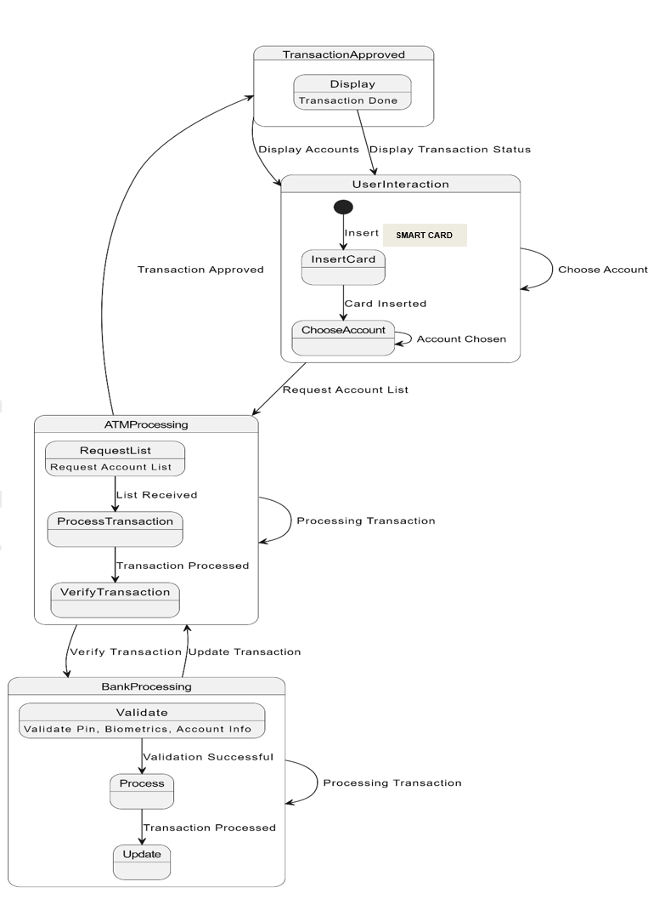

Fig 6.1 State Diagram

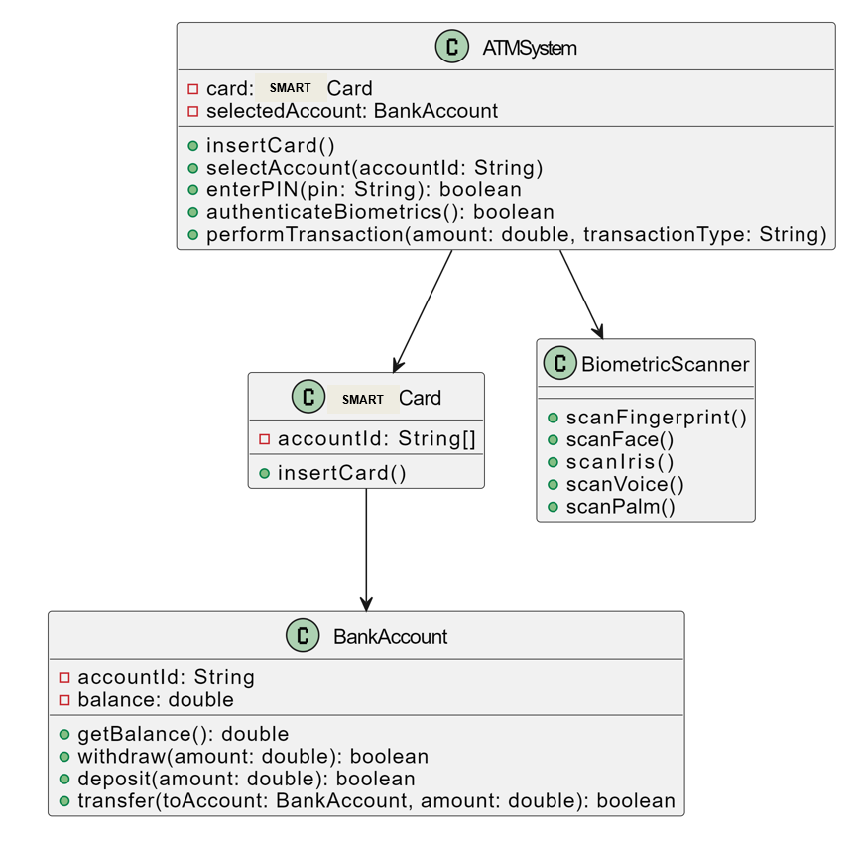
Fig 6.2 Class Diagram

VII.TESTS AND RESULTS
As a result of all the efforts we have put into research and development, there is now available an all-new single Smart card system for accessing several bank accounts with one unified interface; this eliminates the complexities of managing a range of financial portfolios. We have surmounted banking technology issues, authentication protocols, security measures, user experience design and regulatory compliance through utilization of theoretical frameworks, empirical data collection and iterative design processes. The implementation of our framework showed promising results in several important respects. First, functional testing sessions with representative end-user samples provided overwhelmingly positive feedback, indicating high levels of satisfaction with the system user interface, features and functionality by participants appreciated the convenience of navigation, flexible workflow and personalized experience offered by the system with an emphasis on and efforts to facilitate access and maintenance of multiple bank accounts.
Our system implementation has yielded good results for various dimensions. Notably, prototypes of the system in which a small number of end users used it have attracted positive comments about the interface and performance features. Navigation was described as intuitive, workflows streamlined and customers personalized by this application according to participants who found that multiple bank accounts could be accessed with ease due to its efficiency.
The privacy protection rate for the system was satisfactory to the users indicating that trust among users is facilitated by strict security measures that can control frauds.
Fig 7.1 Test Results
Moreover, our platform also has a good security and data protection result. Our encryption technology, authentication procedures and fraud detection systems have been comprehensively tested, then analyzed with positive results in matters of securing sensitive financial information from cyber threats and unauthorized access.
This is how this system was tested just to be sure that it works well with the bank systems we have. That means that this product went through a number of prototypes and pilots in order to match with different ATM networks, payment processing systems, regulatory requirements on the ground. At the same time, industry cooperation among these experts helped make this product to be more scalable, reliable and compliant with standards of those institutions.
Our study also provides insight about people’s behavior, attitude and preference when using banking technology. In addition, surveys and interviews give rich qualitative data on what users need; their pain points and expectations which help us develop our system. Furthermore, our solution caters for different levels of technological skills among bank users through user-centered design principles after incorporating user feedback improving its adoption and usability in diverse contexts.
Our research and development has produced enough evidence confirming that Smart cards can revolutionize banking. The system provides a safe environment, where users can conveniently manage their financial assets. By working towards being in control of one’s finances, the Smart card could completely change individuals’ interactions with their own money.
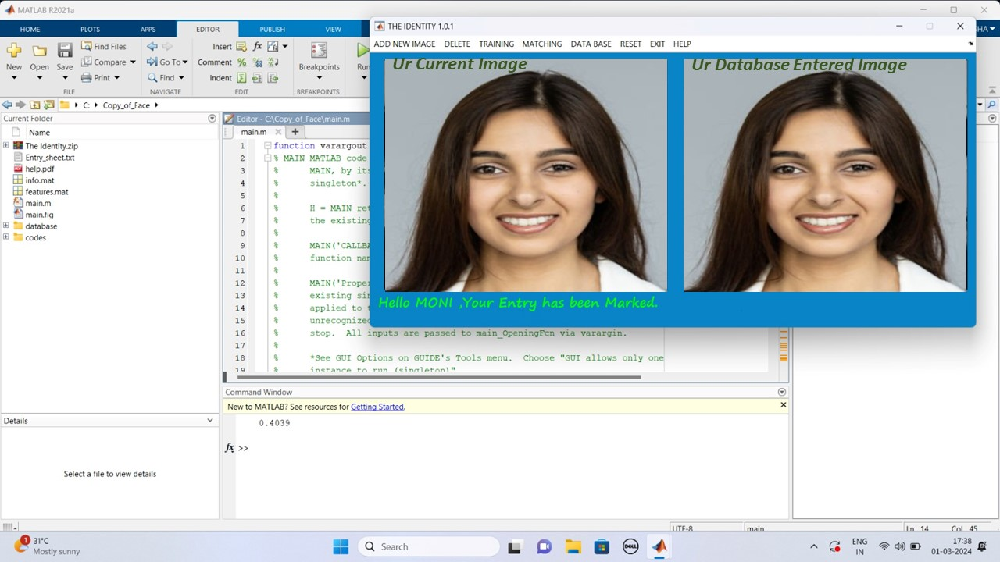
Fig 7.2 Face Recognition
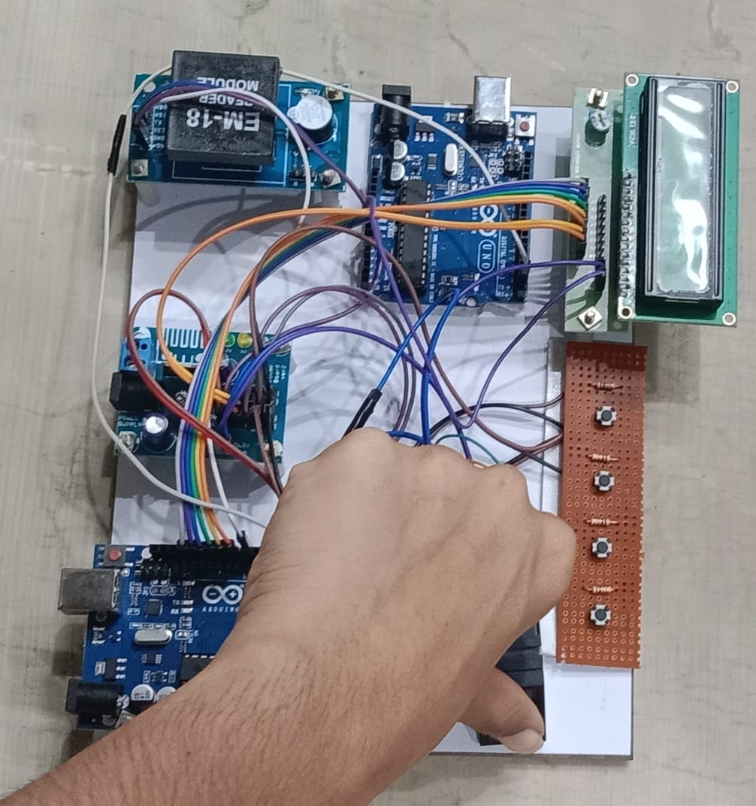
Fig 7.3 Fingerprint Recognition
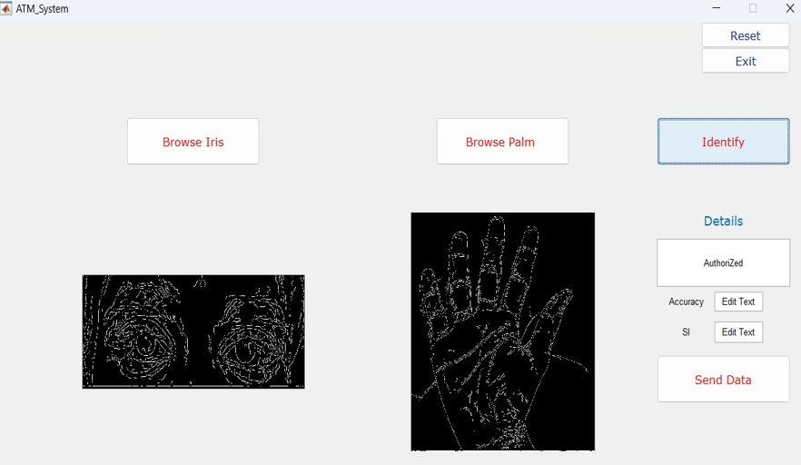
Fig 7.4 Iris and Palm Recognition
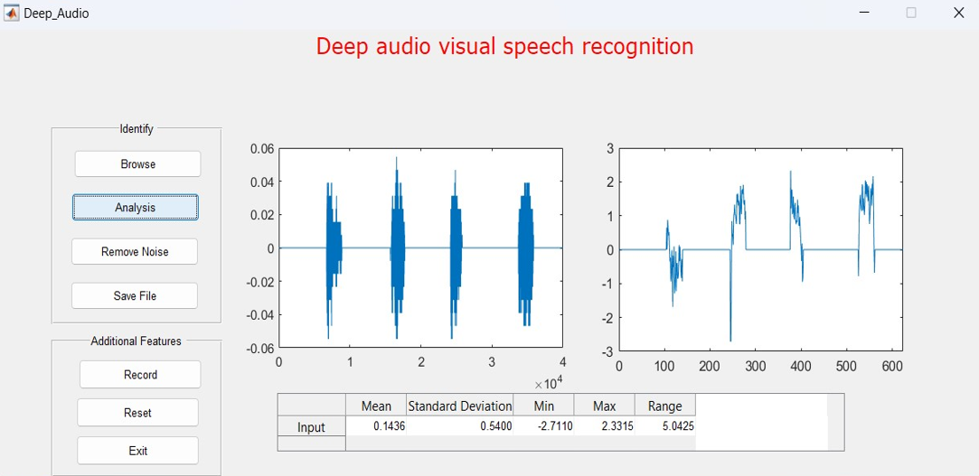
Fig 7.5 Voice Recognition
VIII.FURTHER IMPROVEMENT

The changes in ATMs transactions seem to be moving towards a future that will be characterized by mix of advanced technology solutions facilitating safety, comfort and customer satisfaction. One of the most promising ideas is to adopt several biometric authentication techniques instead of a reliance on PIN numbers only as it was before. In other words, machines will incorporate three biometrics i.e. fingerprint scanning, face recognition and palm or iris detection with voice verification for ATM security arrangements.

The new wave of biometric authentication marks a great change in the way ATM users interact with their devices, making the process of verification safe and easy. Gone are the days when users had to remember difficult PINs; now their bodies become keys to bank accounts. Users can easily access their monetary resources by just scanning or recognizing their own distinctive biological traits thus successfully eliminating pin theft risks and any other unauthorized access.

Besides, the future of ATM transactions will involve sophisticated smart card technologies that further enhance user-friendliness and financial control capabilities. These include Singular Intelligent Cards which come with state-of-the-art encryption and authentication protocols that enable their users to combine several bank accounts into a single dynamic card. This coalescence simplifies the user experience by doing away with multiple cards, thus minimizing the load on memory regarding various PINs.

The anticipated ATM machine is not just an ordinary trading terminal but a reliable financial hub in this era. Pairing the biometric identification with the Singular Intelligent Card makes it simpler for people, thus the feeling of being free and the belief in banking systems. Consequently, these innovations may potentially lead to unimaginable levels of security, convenience, and innovation in the future of ATM transactions; thereby becoming significant milestones for fintech advancement.

IX.CONCLUSION

Finally, our research and development activities have led to the invention of a revolutionary one Smart card system for accessing multiple bank accounts, which will revolutionize the banking sector as we know it. We solved various complexities related to an efficient multi-instrument portfolio management by combining theory, collection of empirical data, iterative design approaches as well as stakeholder engagement and collaboration. For instance, we have made strides in usability, security features, technical viability, compatibility and user satisfaction among others from the deployment of our system.

Also, the user testing sessions have shown that our system is effective in making the process of accessing and managing multiple bank accounts easier; it can be used by non professionals as it has an intuitive interface, straight workflows and individual experiences. On top of that, this solution has been equipped with strong information security measures which help to protect crucial financial data from cyber attacks and limit any unauthorized access hence fostering trust and motivation among customers. The technical feasibility tests conducted as well as the assessment on interoperability has indicated the systems compatibility with the existing banking infrastructures thereby proving its readiness for large scale implementation.

Also our research has given us important insights on users’ behavior, attitude towards and preference of banking technologies which helped us design and develop this system. Through a participatory design methodology that involved iterative prototyping and user feedback analysis we have designed our product to suit all users ranging from beginners to advanced users who want convenience in their banking experience regardless of their place around the world.

The future of banking is taken care of by our one single Smart card system, which provides customers with a secure, handy and user friendly way to manage their different financial portfolios. This could drive innovation, efficiency and empowerment in banking for years and generations to come by simplifying the banking experience and giving users control over it at the same time making it more accessible and peaceful. Our system is on the cutting edge of this digital revolution that has transformed the world of finance as we knew it, ready to change the face of banking forever and lead to an age marked by convenience safety and accessibility around the globe.
REFERENCES

[1] H. U. Khan, M. Z. Malik, S. Nazir and F. Khan, "Utilizing Bio Metric System for Enhancing Cyber Security in Banking Sector: A Systematic Analysis," in IEEE Access, vol. 11, pp. 80181-80198, 2023, doi: 10.1109/ACCESS.2023.3298824.

[2] N. A. Karim, O. A. Khashan, H. Kanaker, W. K. Abdulraheem, M. Alshinwan and A. -K. Al-Banna, "Online Banking User Authentication Methods: A Systematic Literature Review," in IEEE Access, vol. 12, pp. 741-757, 2024, doi: 10.1109/ACCESS.2023.3346045.

[3] Z. Wang, M. Muhammat, N. Yadikar, A. Aysa and K. Ubul, "Advances in Offline Handwritten Signature Recognition Research: A Review," in IEEE Access,vol.11,pp.120222-120236, 2023, doi: 10.1109/ACCESS.2023.3326471.

[4] A. Almadan and A. Rattani, "Benchmarking Neural Network Compression Techniques for Ocular-Based User Authentication on Smartphones," in IEEE Access, vol. 11, pp.36550-36565,2023.

[5] P. Odya, F. Gorski and A. Czyżewski, "User Authentication by Eye Movement Features Employing SVM and XGBoost Classifiers," in IEEE Access, vol. 11, pp. 93341-93353, 2023, doi: 10.1109/ACCESS.2023.3309000.

[6] W. Mu and B. Liu, "Voice Activity Detection Optimized by Adaptive Attention Span Transformer," in IEEE Access, vol. 11, pp. 31238-31243, 2023, doi: 10.1109/ACCESS.2023.
3262518.

[7] C. Busch and B. Liu, "Design of a Batteryless, Wireless, and Secure System-on-Chip Implant for In-Body Strain Sensing," 2023 Working Conference on Software Visualization (VISSOFT), Luxembourg, 2023, pp. 125-129, doi: 10.1109/VISSOFT52517.2023.00024.

[8] D. Benalcazar, J. E. Tapia, S. Gonzalez and C. Busch, "Synthetic ID Card Image Generation for Improving Presentation Attack Detection," in IEEE Transactions on Information Forensics and Security, vol. 18, pp. 1814-1824, 2023, doi: 10.1109/TIFS.2023.3255585.

[9] K. Malinka, O. Hujnak, P. Hanacek and L. Hellebrandt, "E-Banking Security Study—10 Years Later," in IEEE Access, vol. 10, pp. 16681-16699, 2022, doi: 10.1109/ACCESS.2022.
3149475.

[10] A. Sedik et al., "Deep Learning Modalities for Biometric Alteration Detection in 5G Networks-Based Secure Smart Cities," in IEEE Access, vol. 9, pp. 94780-94788, 2021, doi: 10.1109/ACCESS.2021.3088341.

[11] C. -W. Hung, J. -R. Wu and C. -H. Lee, "Device Light Fingerprints Identification Using MCU-Based Deep Learning Approach," in IEEE Access, vol. 9, pp. 168134-
168140, 2021, doi: 10.1109/ACCESS.2021.3135448.

[12] I. Banerjee, S. Mookherjee, S. Saha, S. Ganguli, S. Kundu and D. Chakravarti, "Advanced ATM System Using Iris Scanner," 2019 International Conference on Opto-Electronics and Applied Optics (Optronix), Kolkata, India, 2019, pp. 1-3

[13] S. Gokul, S. Kukan, K. Meenakshi, S. S. V. Priyan, J. R. Gini and M. E. Harikumar, "Biometric Based Smart ATM Using RFID," 2020 Third International Conference on Smart Systems and Inventive Technology (ICSSIT), Tirunelveli, India, 2020, pp. 406-411

[14] D. N. A, A. S, A. Lahari, G. M, P. K N and P. Mugilan, "Smart ATM Card for Multiple Bank Accounts," 2022 International Interdisciplinary Humanitarian Conference for Sustainability (IIHC), Bengaluru, India, 2022, pp. 1228-1232

[15] S. A. Khan and A. A. Abbasi, "Expression-based Security Framework for ATM Networks," 2022 International Conference on Digital Transformation and Intelligence (ICDI), Kuching, Sarawak, Malaysia, 2022, pp. 258-261

